Introduction
In this report, I will be discussing clustering and fitting of my chosen dataset greenhouse, cereal yield and fertilizer.

- Forest and arable land
On Figure 1, I have three countries from first, second and third world. Australia being the first, Mongolia being the second and Brazil as the third. For Brazil, Mongolia and the world, there is a downward trend in forest land whilst a slight to obvious upward trend in arable land for all countries including the world. The most peculiar part for the ‘world’ plot is that there is a sudden shift upwards with arable land since the 2010 and countries like Australia and Mongolia also shows a spike starting in the year 2010. While every country shows a drop in forest land, Australia has managed to increase their forest area drastically since the 2010.
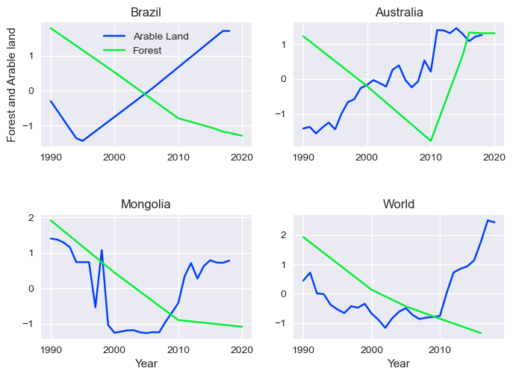
Figure 1: Time series plots of Brazil, Australia, Mongolia and the World
- Correlation between variables
Visually, it appears there is a positive correlation of Greenhouse and Arable land with Australia and Brazil indicating that greenhouse gases increase as arable land increases, whereas we see a loose correlation for Mongolia and World. numerical value are better indicator of correlation and Table 1 shows a valid negative correlation for Brazil in column arable-forest which denote that there is a sign of deforestation but not so for the rest of the countries. Concrete positive correlation for Brazil and World for the increase of greenhouse and arable land while a vague one for world meaning there seems to be a clear relationship between the two variables. Forest-Greenhouse column shows a negative correlation between all columns especially for Brazil and World where it shows a clear indication of increase of greenhouse when forest land is reducing.
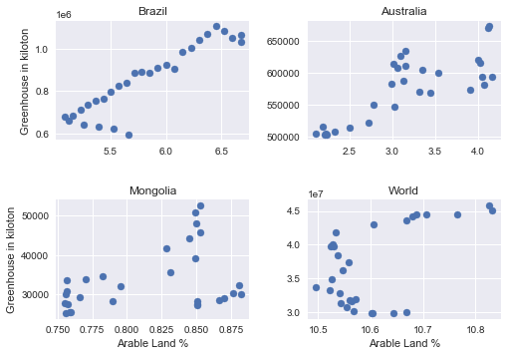
Figure 2 : Correlation plot for Greenhouse in unit of kiloton and Arable land in percentage
 | Arable-Forest | Arable -Greenhouse | Forest-Greenhouse
Brazil | -0.89 | 0.92 | -0.98
Australia | -0.24 | 0.79 | -0.49
Mongolia | 0.29 | 0.386 | -0.65
World | -0.17 | 0.55 | -0.94
Table 1: Correlation of Arable-Forest, Arable-Greenhouse and Forest-Greenhouse between countries and the world
- Statistical properties of Forest Land (Sq Km)
Forest land | Mean (sq km) | Changes % (1990-latest) | Land changes (sq km)
Brazil | 5x10⁶ | - 15.669 % | -9.2x10⁵
Australia | 1.3x10⁶ | 0.09 % | 0.09
Mongolia | 1.4x10⁵ | - 1.25 % | -1792.2
World | 4.05x10⁷ | - 3.21 % | -1.3x10⁶
Table 2: Mean and percentage change of forest land
Table 2 shows that Brazil has the highest drop in percentage. However, Australia has increased their forest as of 2020 ever since the sudden shift in forest area since the 2010. But there is clear evidence that forest land is decreasing around the world, and it is a sign of concern since climate change are worsening.

